**PROJECT: Implement Spring Security with Authentication .**

**Developer Name:** Nellore Sri Lavanya

This document contains contents for:

* Project Description
* Flow of the Application
* Core concepts used in project
* Conclusions.

**1.Project Description:**

* As a developer, build Authentication Provider in Spring Security.
* Create a maven project for security login

**2.Application Flow:**

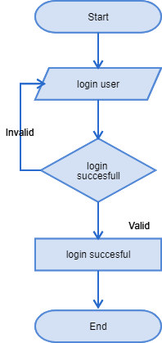

**3.Core concepts used in project:**

● Node.js  
● Jenkins  
● Angular Application

**Conclusion:**

* This project is designed for Implement Spring Security with Authentication .